**A Student Guide to Submitting a Course Amendment Request on**

**Self-Service**

**INTRODUCTION**

A new feature/functionality has been added on the Student Self-Service portal to enable a student to submit a request to either Drop/De-reregister a course or add/register new course to the faculty for approval. The faculty can decline such a request and students will receive an email notification informing them that the request has not been approved.

If the request to amend registration is approved by the faculty, an email notification will be sent to the student to confirm that the request was approved and processed by the faculty. The student can order or request a proof of registration from the Student Self-Service to get an updated list of registered/enrolled courses.

**SUBMITTING A COURSE AMENDMENT REQUEST**

1. Log on to the Student Self-Service portal
2. Click on the **Academic Information** tile

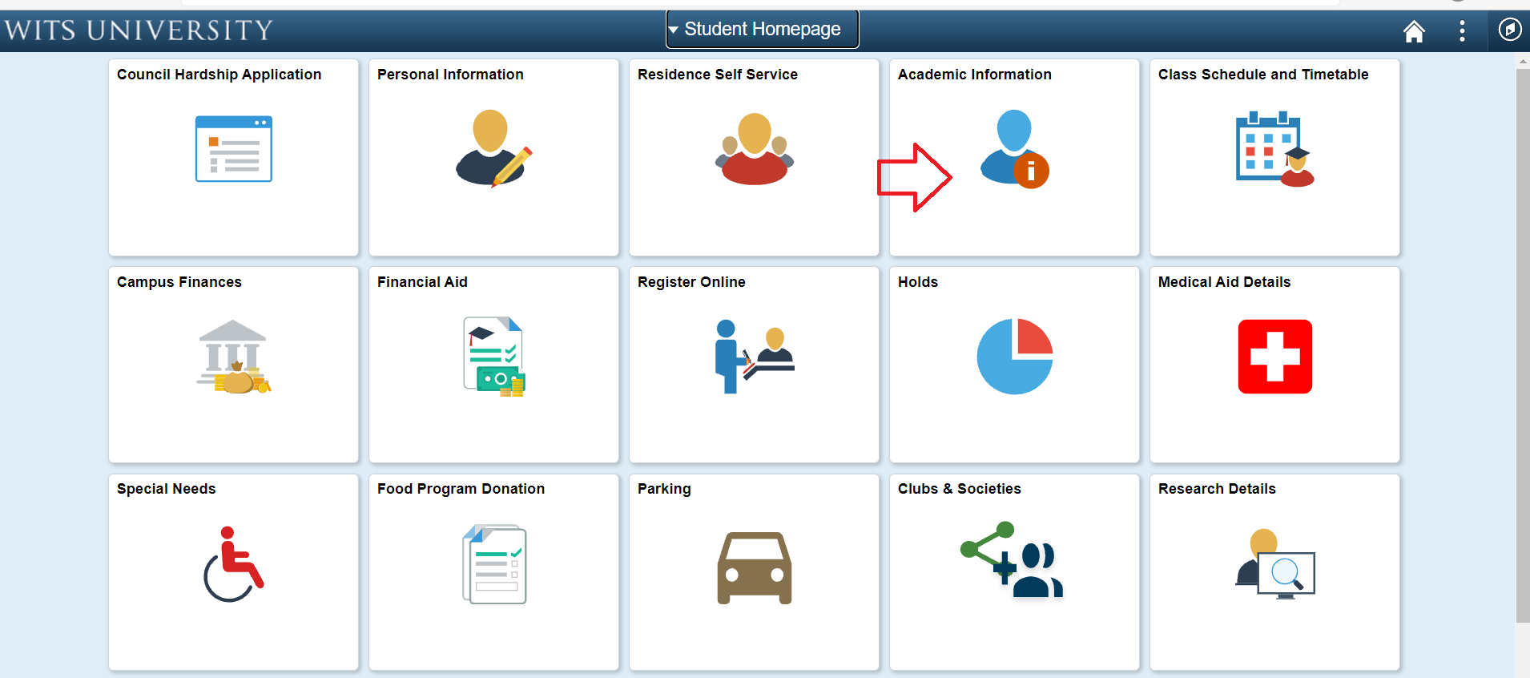

1. Click on **Online Course Amendment** menu option

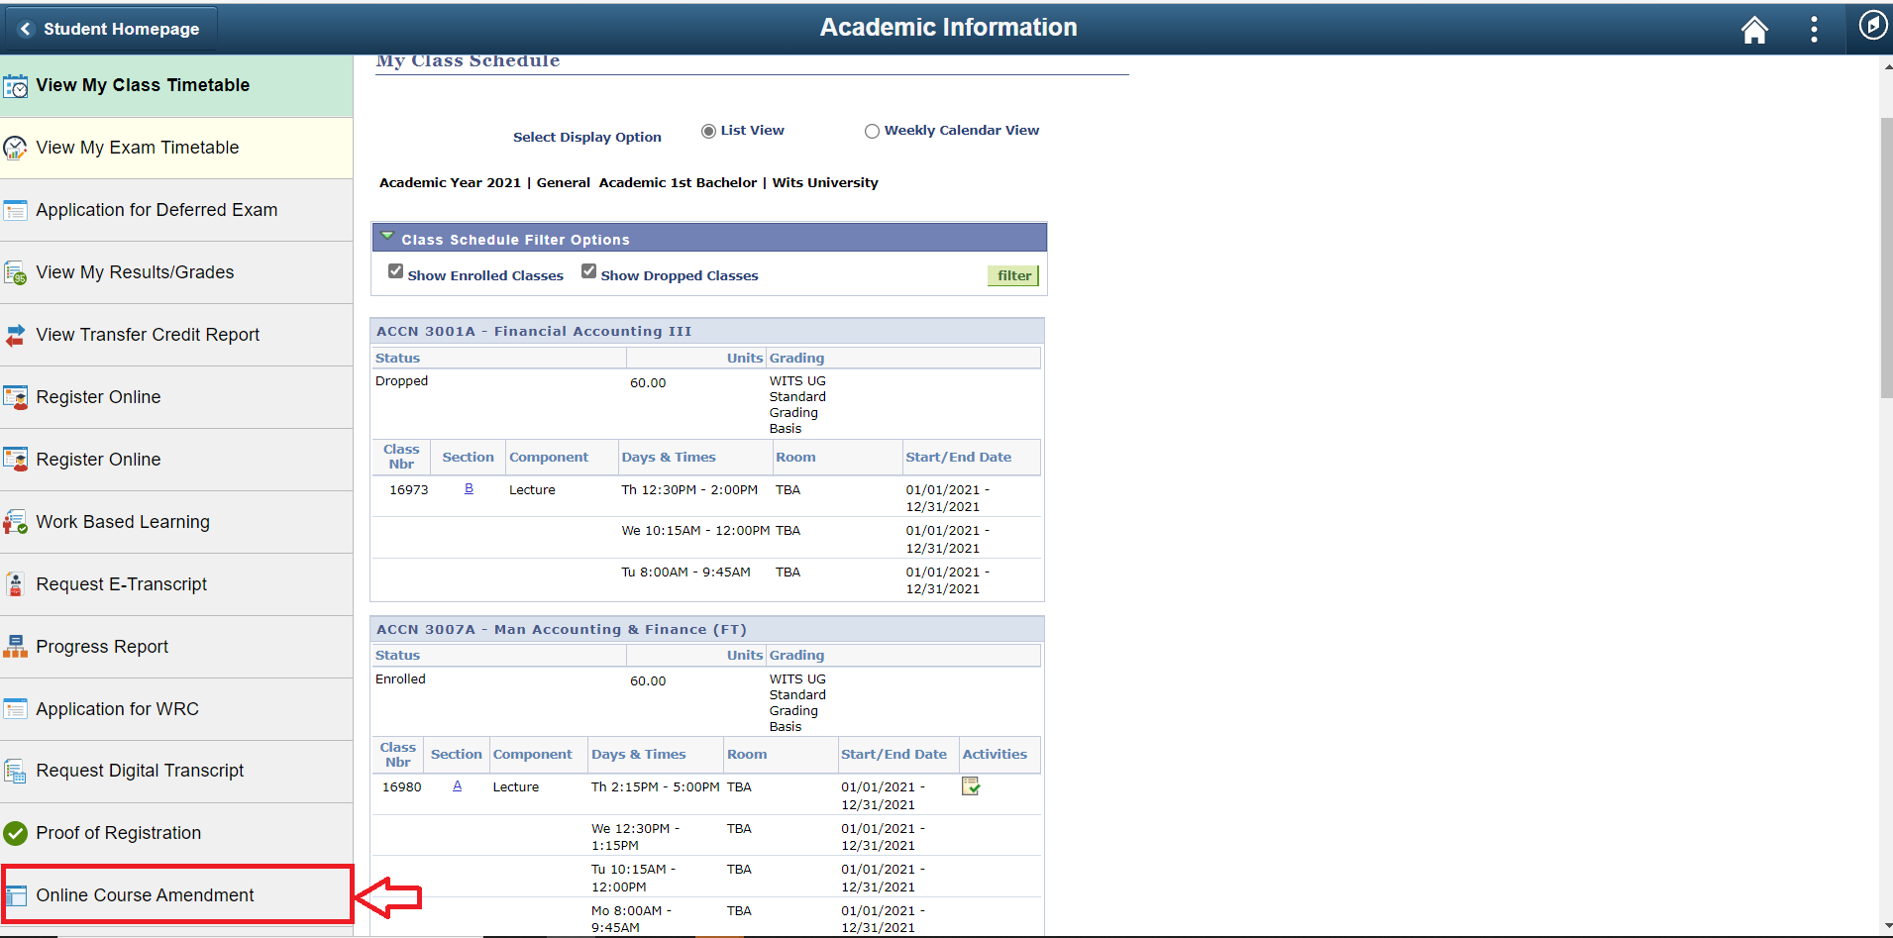

1. Select the course/s to be dropped or added then the click on the **submit** button to submit the request to the Faculty Office

